Year 3 (Maple) Long Term Plan
 | Autumn Term |  | Spring Term |  | Summer Term
Topic | Anglo-Saxons |  | Volcanoes |  | Ancient Egyptians
Class Book | Beowulf  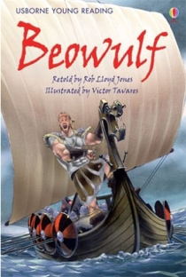 |  | Escape from Pompeii  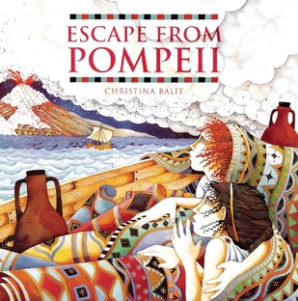 |  | 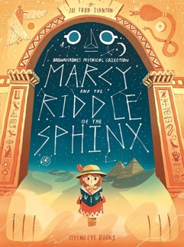  Marcy and the Riddle of the Sphinx
 | Autumn 1 | Autumn 2 | Spring 1 | Spring 2 | Summer 1 | Summer 2
English | Instructions  Character and Setting Descriptions | Narrative: Hero Myth/Legend  (Writing Assessment)  Letter Writing | Non-chronological report  Narrative: Historical Fiction | Diary Entry  (Writing Assessment)  Poetry | Explanation Text  Newspaper Report | Adventure Narrative  Persuasive Writing
Reading | Topic Book: Beowulf  Ninja Comp: Birds of Prey | Topic Book: Beowulf  Ninja Comp: Anglo-Saxons | Topic Book:  Escape from Pompeii | Topic Book:  Escape from Pompeii | Topic Book: Marcy and the Riddle of the Sphinx | Topic Book: Marcy and the Riddle of the Sphinx
Maths | Place Value  Addition and Subtraction | Addition and Subtraction  Multiplication and Division A | Multiplication and Division B  Length and Perimeter | Fractions A  Mass and Capacity | Fractions B  Money  Time | Time  Shape  Statistics
Science | Animals, including Humans | Forces and Magnets | Rocks |  | Light | Plants
Topic (History/  Geography) | Anglo-Saxons  (Was Saxon Britain a dark time in British history?)  - When did the Anglo-Saxons arrive?  - Why did the Anglo-Saxons invade?  - How can we possibly know where they settled?  - How do we know they settled in Lambley? (Local History Study)  - What does the mystery of the empty grave tell us about Saxon Britain?  - How were the Saxons able to see off the Viking threat?  - Just how great was King Alfred, really?  - So how dark were the Dark Ages, really?  - Double Page Spread |  | Volcanoes  (Would you live next to a volcano?)  - What is a volcano?  - What happens when a volcano erupts?  - What are the features of a volcano?  - What are tectonic plates?  - What is life like in volcanic areas?  - What is life like in volcanic areas? (Part 2)  - Double Page Spread |  | Ancient Egyptians  (What secrets does Ancient Egypt hold?)  - What do we mean by Ancient Egypt?  - How can we discover what Ancient Egypt was like 5,000 years ago?  - What secrets of Ancient Egypt are revealed by the pyramids?  - Why is Tutankhamun’s tomb important?  - What did the Ancient Egyptians believe about life after death and how do we know?  - What did Ancient Egypt have in common with other civilisations and how do we know?  - Double Page Spread
Computing | E-Safety | Computer systems and networks 1: Networks | Computer systems and networks 3: Journey inside a computer | Creating Media: Video Trailers | Programming: Scratch | Programming: Scratch
Art | Focus Artist: Georges Seurat  Skill: Painting | Anglo-Saxons  Skill: Drawing | Focus Artist: Segal  Skill: 3D Sculpture | Volcanoes  Skill: Painting | Focus Artist: O’Keefe  Skill: Printmaking | Ancient Egyptians  Skill: Drawing
Design and Technology | Cooking and nutrition: Eating seasonally |  | Mechanical systems: Pneumatic Toys |  | Electrical systems: Electric poster
Religious Education | Beliefs and Questions | Religion, family and community: Prayer | Worship in sacred places |  | Inspiration people from the past
Physical Education | IR
RSE | What can affect my health?  What is a balanced lifestyle?  What is health and safety?  How does smoking damage my health?  Who can help me be safe?  What is restorative justice? |  | What are my rights and responsibilities?  What happens if I break a rule?  Why should I tell the truth?  What does honesty really mean?  What do I do when my friends are sad?  Who do my actions affect? |  | What are my relationship rights and responsibilities?  How do I raise my concerns?  What’s a community?  How can we be different?  Who else lives in my region?  Who else lives in the UK?
French | EB
Music | EB

